# MySQL Installation

**Before you begin:**

Download the MySQL binary by going to <http://www.mysql.com> and clicking on the ‘Downloads (GA)’ Tab. Once you’re in that tab, click on the download link under ‘MySQL Community Server.’ Select the platform that MySQL is going to run under and click download. Once you clicked download, you’ll be prompted to login, ignore this and go to the bottom of the screen and click ‘No thanks, just take me to the downloads!’ When you get to the next page, select the mirror closest to you and your download will begin.

**Step 1:**

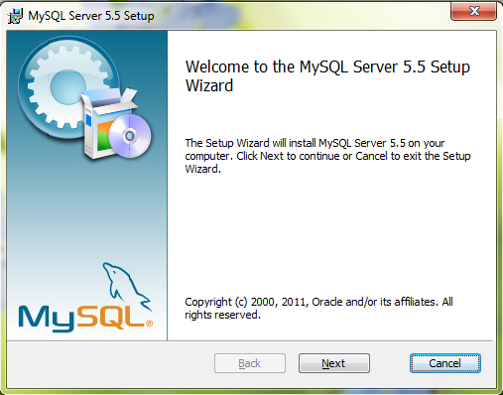Run the binary and you will get a screen like below prompting you to start the setup. In this screen, click ‘Next’ to proceed to the next step.

**Step 2:**

On this screen, you’re going to need to check the ‘I accept the terms in the License Agreement’ checkbox and then click ‘Next’ to proceed.

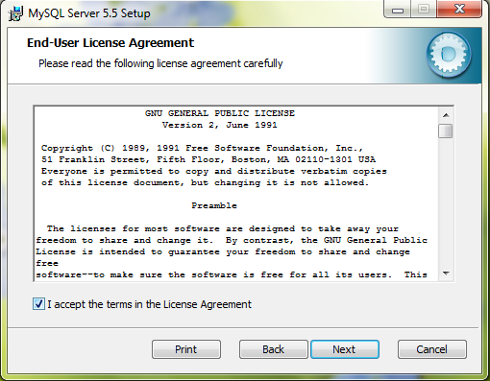

**Step 3:**

On this screen, we will click on ‘Typical’.

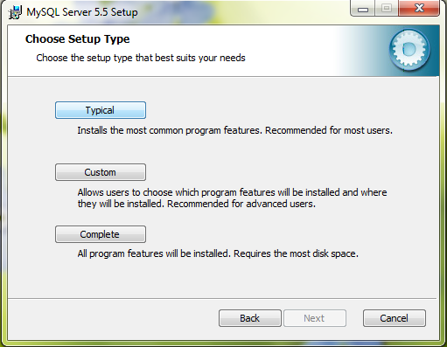

**Step 4:**

On this screen, we begin the installation by clicking ‘Install.’

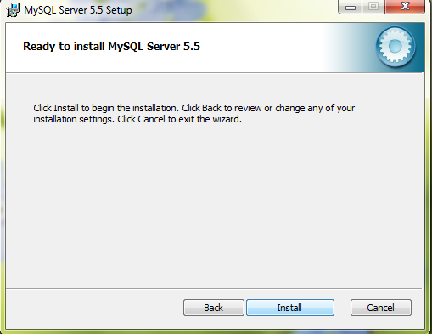

**Step 5:**

You will have another window popup over your previous window. Once this happens, click ‘Next’ to proceed through the installation.

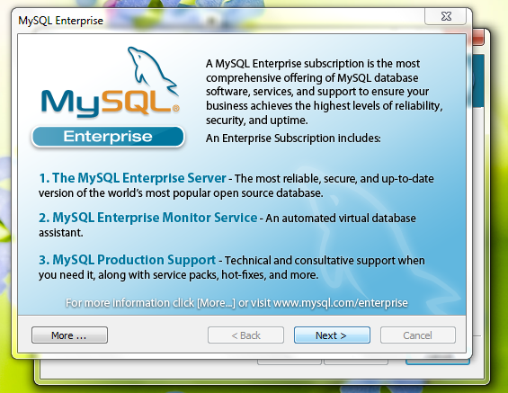

**Step 6:**

On this screen, you will receive some more information about MySQL Enterprise Monitor Service. You can ignore this and proceed to the next screen by clicking ‘Next.’

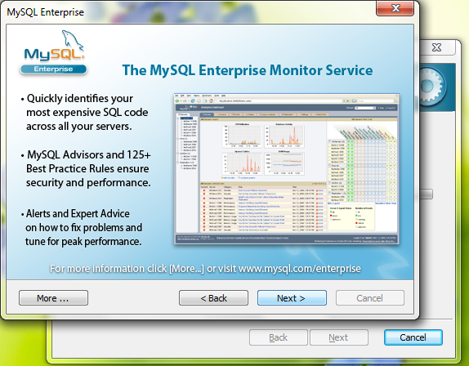

**Step 7:**

Alright, you now have finished the setup wizard. Click ‘Finish’ to have it launch the MySQL Instance Configuration Wizard.

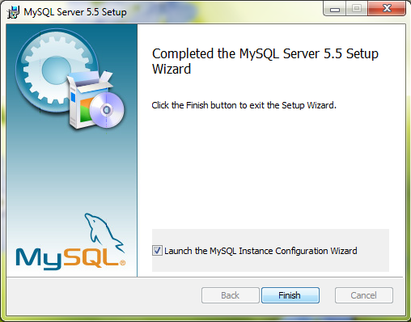

**Step 8:**

This is the first screen in the MySQL Server instance configuration wizard. Click ‘Next’ to continue.

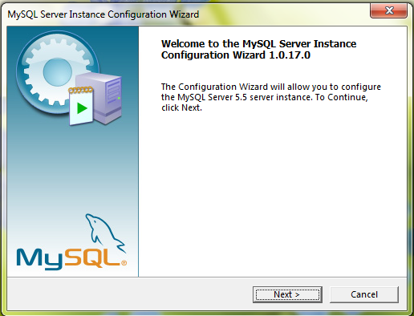

**Step 9:**

On this screen, we want to choose ‘Detailed Configuration’ so that we can configure MySQL for our needs. Once you have ‘Detailed Configuration’ selected, click ‘Next.’

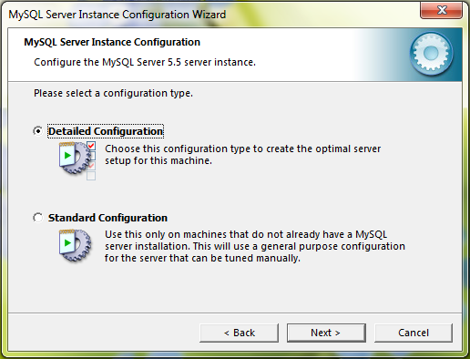

**Step 10:**

This screen is important, as we have many selections. If you are planning on setting up your machine just for development, select ‘Developer Machine.’ If you know that MySQL is going to need to run side-by-side with the OpenEHS project, select ‘Server Machine.’ If you are sure that this machine is going to be dedicated to run ONLY the MySQL database, select ‘Dedicated MySQL Server Machine.’ After you make your selection, click ‘Next.’

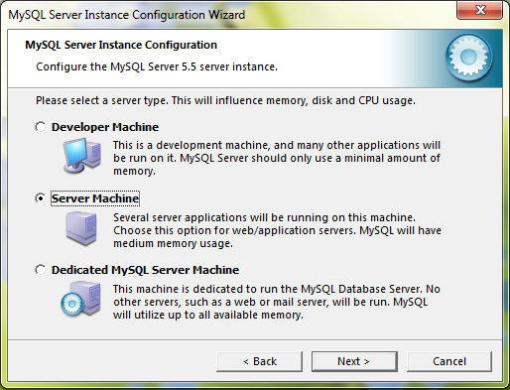

**Step 11:**

On this screen, we are going to select ‘Multifunctional Database’ and click ‘Next.’

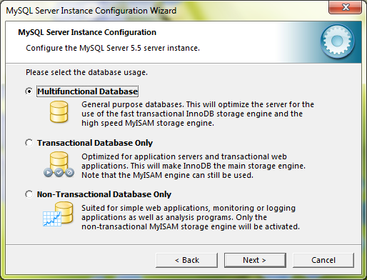

**Step 12:**

On this screen, the wizard is trying to determine where to install the MySQL files. The default is fine unless you want to install it where you would like. Click ‘Next’.

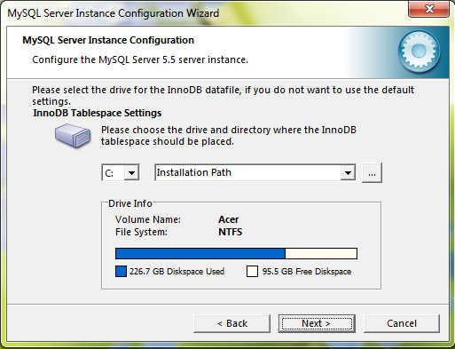

**Step 13:**

On this screen, It is wanting to set the amount of concurrent connections to the database. If you know that only a small amount of people will be using OpenEHS, select ‘Decision Support (DSS)/OLAP.’ If you know that there are going to be a lot of computers accessing the OpenEHS application, select ‘Online Transaction Processing (OLTP).’ Then click ‘Next’.

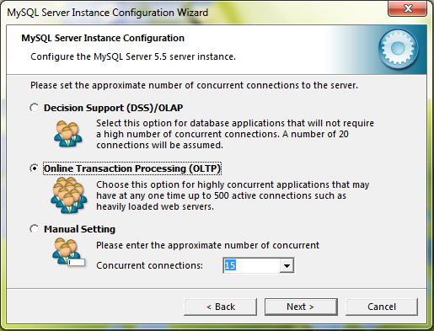

**Step 14:**

Defaults on this page are fine. Click ‘Next’ to continue.

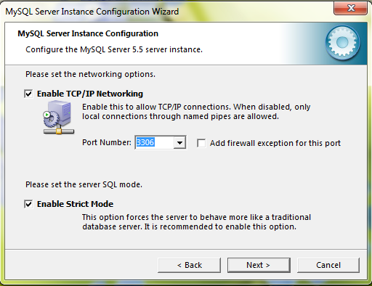

**Step 15:**

The wizard wants to know what character set you’re going to be using for data. If you’re using the application in a place where the language uses the standard character set (like English, Spanish, etc) then select ‘Standard Character Set.’ If you’re going to be using the application in a place using a language with characters that aren’t default in most character sets, select ‘Best support for multilingualism.’ Click ‘Next.’

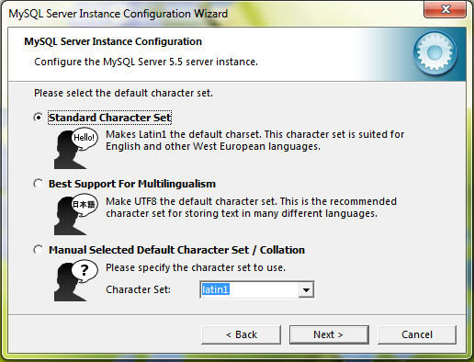

**Step 16:**

On this step, check the ‘Include Bin Directory in Windows PATH’ so that the application can perform database actions such as backup/restore. Click ‘Next.’

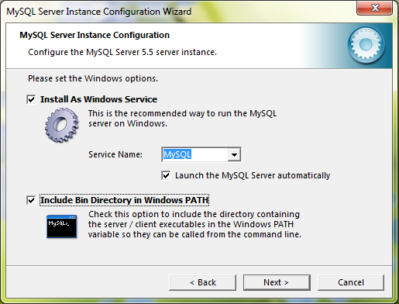

**Step 17:**

Create a password and enter it into the new root password and confirm text boxes. Click ‘Next.’

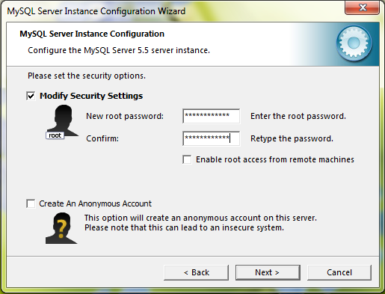

**Step 18:**

Click ‘Execute’ to have MySQL created.

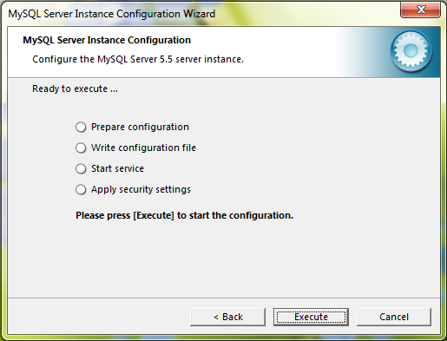

You’re finished!